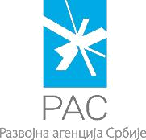
FORM 2

SUPPORT PROGRAM FOR BUSINESS START-UPS – START UP PROGRAM

STATEMENT
on Accepting the Conditions of the Public Call

As a legal representative of business entity ______________________________

(name of business entity)

I declare that I accept all the conditions stated in the Public Call for the award of funds within the Support program for business start-ups in 2017 – Start-up Program.

Otherwise, I agree that the submitted application be refused.

Also, I declare under penalty that:

all submitted copies correspond to the original; all cited information is true and corresponds to the actual state;

for the same activities I did not use funds from other sources; all activities were implemented with positive legal regulations.

In ___________________ |  | Legal representative
Date:_______________ | L.S. | _________________________

Belgrade, Kneza Miloša 12 е-mail: startup@ras.gov.rs www.ras.gov.rs

